St Judes GAA – Garda Vetting and Safeguarding Guide
Garda vetting is non- transferable to other organisations and Garda Vetting from other organisations cannot be accepted by the GAA.
The below volunteers must complete Garda Vetting and Safe Guarding (Children First) before taking up a role with the club
- Coaches/managers with players 18 years and under
- Organisers of underage activities
- Referees of underage activities
- Coaches between 16-18 years for camps (parental consent required)
- Club Officers, Photographers and regular guest speakers
Vetting is required every 3 years – you will be notified of expiry via an email from Foireann however this usually ends up in Junk Mail. Please ensure you have a reminder set to update your vetting after 3 years.
Your vetting status can be found in your Foireann profile under the Qualifications & Vetting tab.
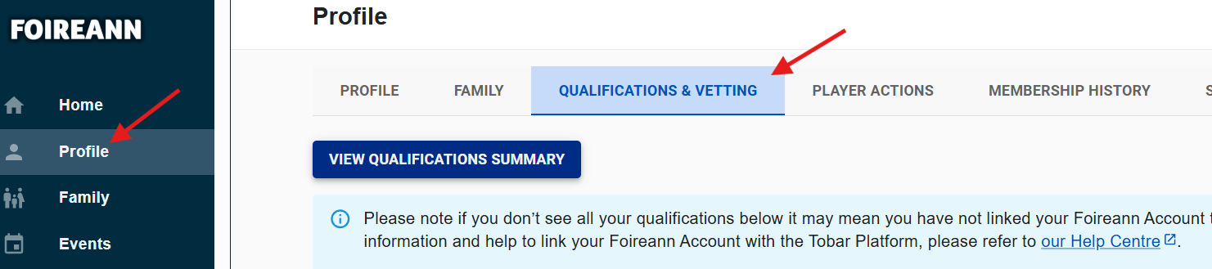

Steps to set up Garda Vetting
- Create an account or log in to Foireann to begin the vetting process.
Foireann
- Input current details on your profile. Please ensure these are correct and complete e.g. Date of birth, Eircode/Postcode and email address. Your details must match your Photo ID and Address Verification documents
- You can print out your NVB1 Vetting Invitation Form from Foireann (which will auto populate your details from your account) or you can request one from the Club Children’s Officer (CCO) and complete manually
- Complete the GAA NVB1 Invitation Form and meet your CCO in person.
You must provide:

- completed NVB1 Vetting Invitation Form
- a copy of photo ID (must comply with accepted documentation table)
- a copy proof of address within 6 months of issue (must comply with accepted documentation table)
The full list of documents which are accepted for verification can be found here
- Your CCO, who is the Validator, will complete and sign off the GAA Identity Document Validation Form in your presence and shall retain the hard copy of your GAA NVB1 Invitation form for six months.
- You must take a copy (or a photo) of the completed GAA NVB1 Invitation Form and the Identity Document validation Form for upload to Foireann to complete your application
When the above steps are completed
- Log in to Foireann
- Click on Qualifications and Vetting Tab
- Click on the ‘Apply to be Vetted’ Tab then select your Club and or Association you wish to be vetted for and the role you are applying for vetting**.
Please refer to the list of roles in the link l1ydpmavpcuytsttnpog.pdf
- Upload a copy or screenshot of all documents and forms validated by your CCO as part of your vetting application.
- Ensure the ID and proof of address are the same documents presented to the CCO.
- Once you complete the GAA NVB1 Vetting Invitation Form the information provided is forwarded to the NVB by the GAA.
- You will receive an email to your email address on your Foireann profile with NVB Vetting Invitation to complete (please be vigilant for this email)
- Complete this invitation immediately as it expires after 30 days and the process will have to recommence. Include all details requested.

Useful video link Applying for Garda Vetting on Foireann - YouTube

Safeguarding
You are also required to complete Safe-Guarding 1 (Children First) every 3 years. This is done through the GAA learning Platform Tobar
Welcome to TOBAR | Tobar
Click on the Safeguarding area as per below


Navigate to the safeguarding courses and select either face-to-face or the online refresher. The online refresher can only be completed if your previous course was face-to-face and has not yet expired.
Please note the important statement below
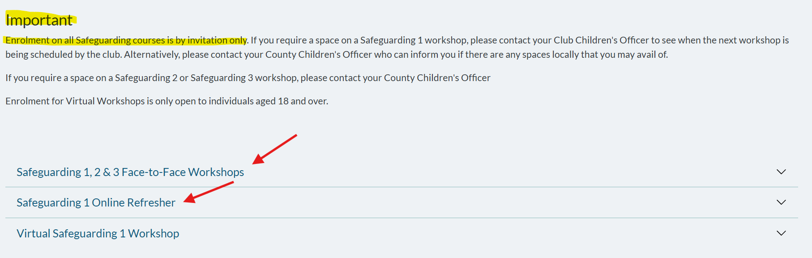

You will need a key code to register for an St Judes organised safeguarding course. Please contact childrensofficer@stjudesgaa.ie
These courses will be run periodically throughout the season and it is your responsibility to make yourself available to attend.

