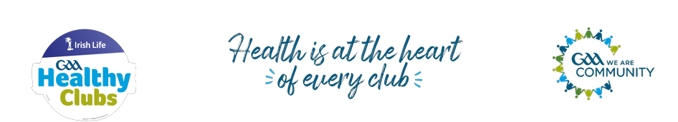
What is the GAA Healthy Club Progam?
The Irish Life GAA Healthy Club Program is a nationwide initiative developed by the Gaelic Athletic Association (GAA) in partnership with Irish Life. Its aim is to support GAA clubs in becoming hubs for health and wellbeing within their communities. The program provides clubs with guidance and resources to promote physical activity, healthy eating, mental wellbeing, and community engagement, fostering a holistic approach to health for all members and the wider community.
St Judes Accreditation
Thanks to the dedication and collaboration of our Healthy Club team, our club members and the wider community, we achieved Foundation status in 2023. Following a successful reassessment, our continued commitment has enabled us to secure re-accreditation in 2025, reflecting our shared effort and ongoing focus on promoting health and wellbeing in our club and community.

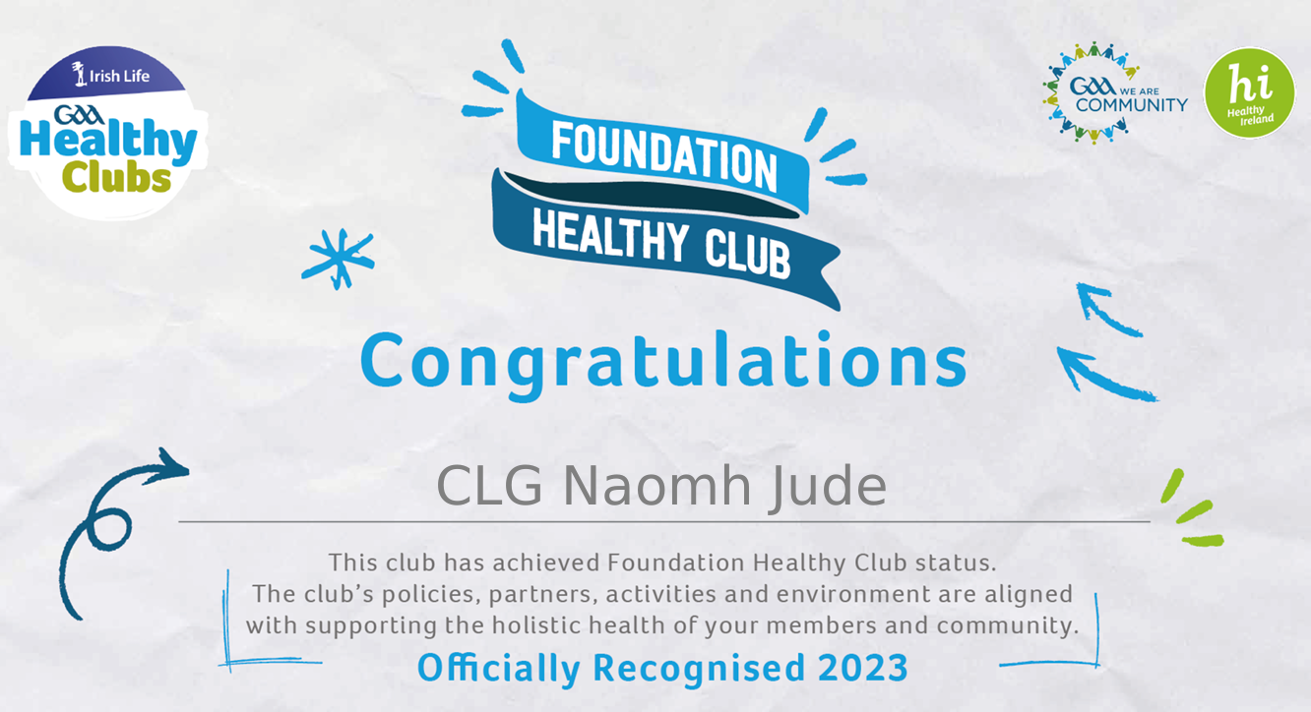
Foundation level maintained and re-accredited in 2025
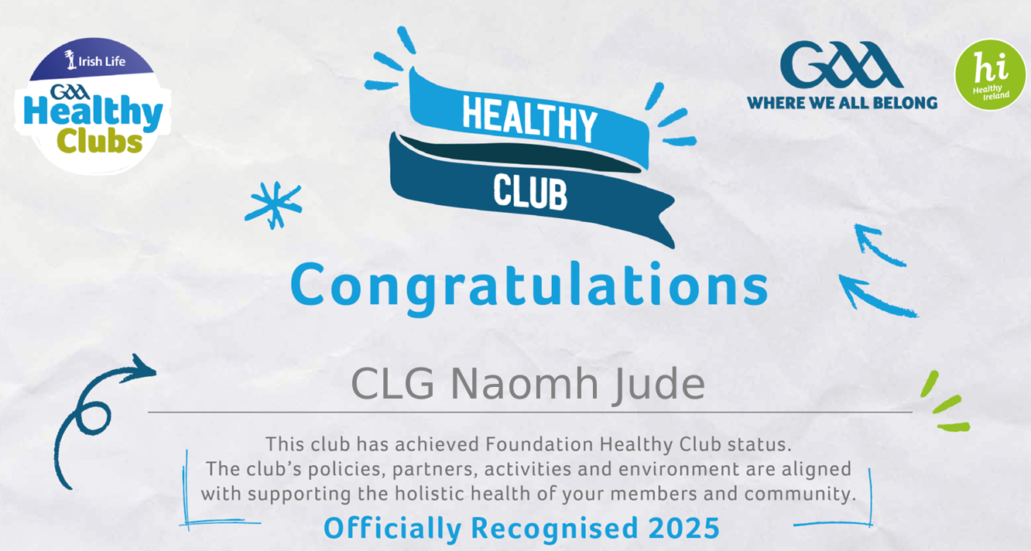

Together, our club St Judes and the wider community have completed activities under the Healthy Club designated banners, demonstrating our collective commitment to promoting health and wellbeing for our members and the broader community. These activities have included physical fitness and team events, diversity and inclusion initiatives, and mental health awareness campaigns, all aimed at fostering a supportive and inclusive environment for everyone involved.

